**Laporan Praktikum**

**Praktikum Bahasa Pemrograman**

**Dosen pengampu : Dede Husen, M.Kom.**



**Nama : Bayu Imantoro**

**NIM : 20230810089**

**Kelas : TINFC – 2023 – 04**

**Teknik Informatika**

**Fakultas Ilmu Komputer**

**Universitas Kuningan**

PRAKTIKUM

1. Pemrograman -1
2. Buat projek baru Java Class Library dengan nama Apllet

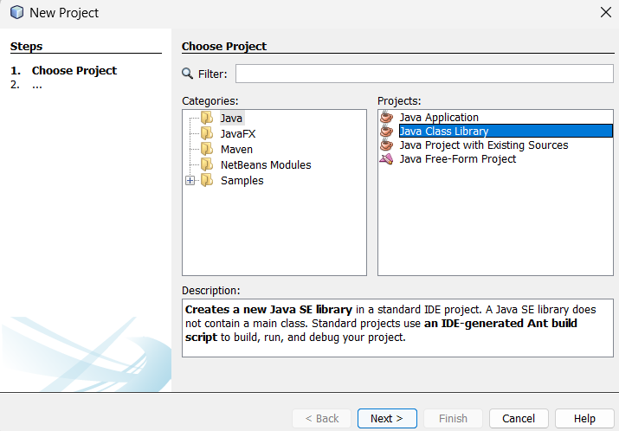

1. Buat Java Class Applet Baru dengan nama BP1_M2_P1_NamaAnda

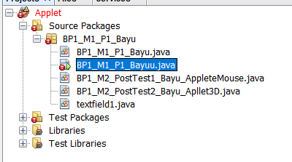

1. Lengkapi program seperti berikut :

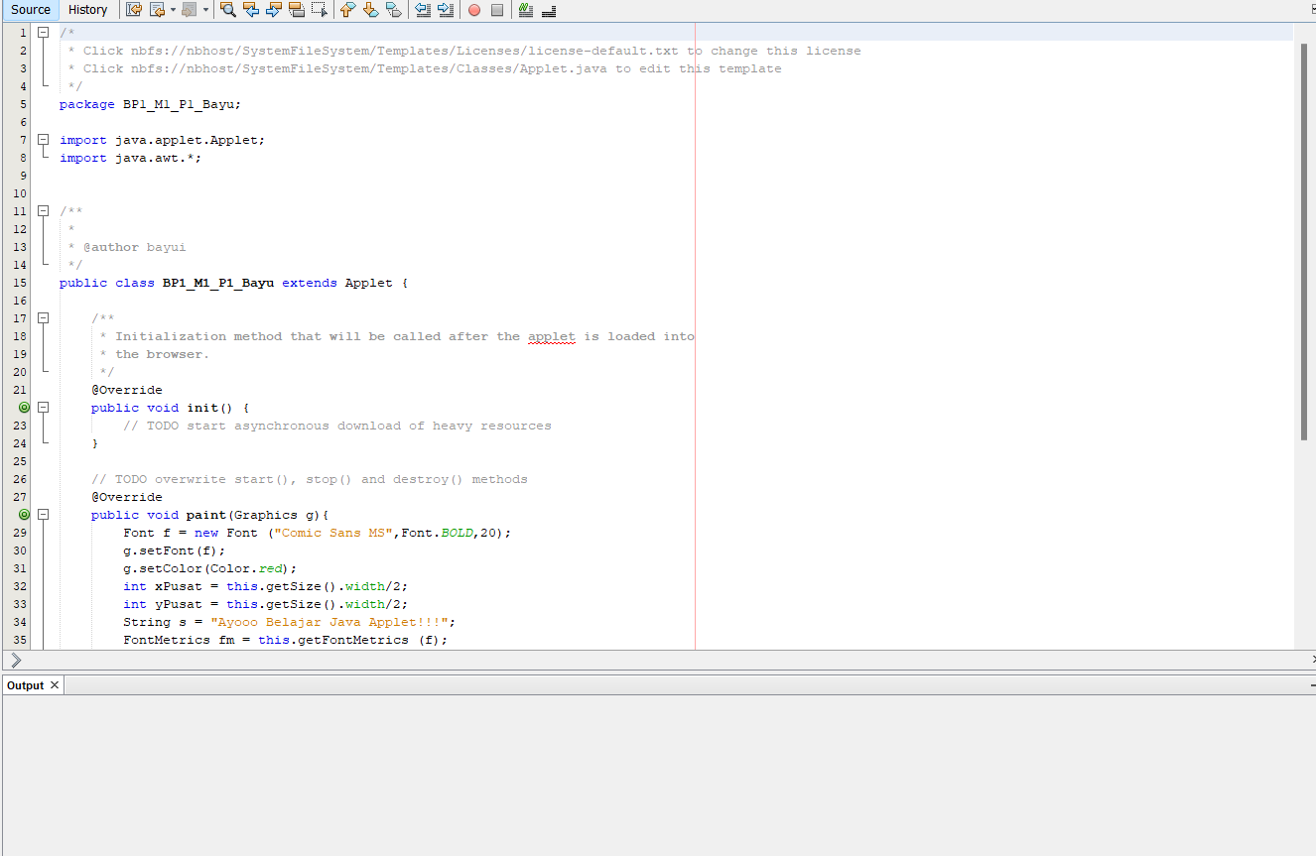

1. Run, lihat dan analisis hasilnya => Jika ada kesalahan, silahkan diperbaiki

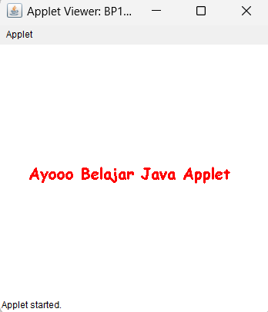

Analisis

Program Applet ini berfungsi untuk menghasilakn kata Ayoo Belajar Java Script dengan warna merah

PRETEST

1. Tuliskan bentuk umum struktur program applet java

/*

* To change this license header, choose License Headers in Project Properties.

* To change this template file, choose Tools | Templates

* and open the template in the editor.

*/

package BP1_M1_P1_Bayu;

import java.applet.Applet;

import java.awt.Graphics;

public class text extends Applet {

public void paint(Graphics g) {

g.drawString("Bayu Imantoro", 50, 50);

}

}

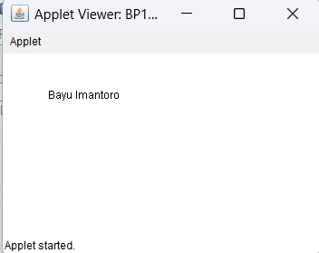

POSTEST

1. Buat file applet baru dengan nama BP1_M2_Postest1_Nama_AppletMouse

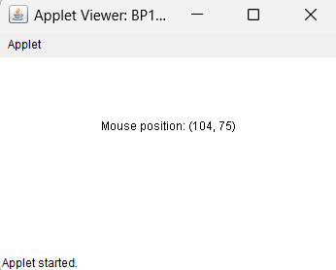

/*

* Click nbfs://nbhost/SystemFileSystem/Templates/Licenses/license-default.txt to change this license

* Click nbfs://nbhost/SystemFileSystem/Templates/Classes/Applet.java to edit this template

*/

package BP1_M1_P1_Bayu;

import java.applet.Applet;

import java.awt.Graphics;

import java.awt.event.MouseEvent;

import java.awt.event.MouseMotionListener;

public class MousePositionApplet extends Applet implements MouseMotionListener {

private int x = 0;

private int y = 0;

@Override

public void init() {

addMouseMotionListener(this);

}

@Override

public void paint(Graphics g) {

g.drawString("Mouse position: (" + x + ", " + y + ")", x, y);

}

@Override

public void mouseMoved(MouseEvent e) {

x = e.getX();

y = e.getY();

repaint();

}

@Override

public void mouseDragged(MouseEvent e) {

}

}

1. Buat file applet baru dengan nama BP1_M2_Postest2_Nama_Applet3D

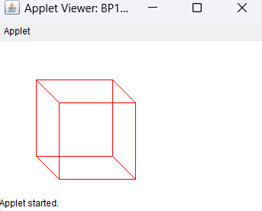

/*

* To change this license header, choose License Headers in Project Properties.

* To change this template file, choose Tools | Templates

* and open the template in the editor.

*/

package BP1_M1_P1_Bayu.tugas;

/**

*

* @author bayui

*/

import java.applet.Applet;

import java.awt.Color;

import java.awt.Graphics;

public class BP1_M2_PostTest2_Bayu_Apllet3D extends Applet {

@Override

public void paint(Graphics g) {

// mengatur warna untuk garis kubus

g.setColor(Color.RED);

int[][] points = {

{50, 50}, // Titik 0

{150, 50}, // Titik 1

{150, 150}, // Titik 2

{50, 150}, // Titik 3

{80, 80}, // Titik 4 (Titik belakang)

{180, 80}, // Titik 5 (Titik belakang)

{180, 180}, // Titik 6 (Titik belakang)

{80, 180} // Titik 7 (Titik belakang)

};

drawCube(g, points);

}

private void drawCube(Graphics g, int[][] points) {

// gambar sisi depan

g.drawLine(points[0][0], points[0][1], points[1][0], points[1][1]); // Garis 0-1

g.drawLine(points[1][0], points[1][1], points[2][0], points[2][1]); // Garis 1-2

g.drawLine(points[2][0], points[2][1], points[3][0], points[3][1]); // Garis 2-3

g.drawLine(points[3][0], points[3][1], points[0][0], points[0][1]); // Garis 3-0

// gambar sisi belakang

g.drawLine(points[4][0], points[4][1], points[5][0], points[5][1]); // Garis 4-5

g.drawLine(points[5][0], points[5][1], points[6][0], points[6][1]); // Garis 5-6

g.drawLine(points[6][0], points[6][1], points[7][0], points[7][1]); // Garis 6-7

g.drawLine(points[7][0], points[7][1], points[4][0], points[4][1]); // Garis 7-4

// menghubungkan sisi depan dan belakang

g.drawLine(points[0][0], points[0][1], points[4][0], points[4][1]); // Garis 0-4

g.drawLine(points[1][0], points[1][1], points[5][0], points[5][1]); // Garis 1-5

g.drawLine(points[2][0], points[2][1], points[6][0], points[6][1]); // Garis 2-6

g.drawLine(points[3][0], points[3][1], points[7][0], points[7][1]); // Garis 3-7

}

}

TUGAS

1. /*

* To change this license header, choose License Headers in Project Properties.

* To change this template file, choose Tools | Templates

* and open the template in the editor.

*/

package BP1_M1_P1_Bayu.tugas;

/**

*

* @author bayui

*/

import java.applet.Applet;

import java.awt.Button;

import java.awt.GridLayout;

import java.awt.Label;

import java.awt.TextField;

import java.awt.event.ActionEvent;

import java.awt.event.ActionListener;

public class BP1_M2_Tugas1_Bayu_AppletePerhitungan extends Applet implements ActionListener {

private TextField num1Field, num2Field, resultField;

private Button addButton, subtractButton, multiplyButton, divideButton;

@Override

public void init() {

setLayout(new GridLayout(5, 2, 5, 5));

num1Field = new TextField(10);

num2Field = new TextField(10);

resultField = new TextField(15);

resultField.setEditable(false);

addButton = new Button("+");

subtractButton = new Button("-");

multiplyButton = new Button("*");

divideButton = new Button("/");

add(new Label("Angka 1:"));

add(num1Field);

add(new Label("Angka 2:"));

add(num2Field);

add(new Label("Hasil:"));

add(resultField);

add(addButton);

add(subtractButton);

add(multiplyButton);

add(divideButton);

addButton.addActionListener(this);

subtractButton.addActionListener(this);

multiplyButton.addActionListener(this);

divideButton.addActionListener(this);

}

@Override

public void actionPerformed(ActionEvent e) {

try {

double num1 = Double.parseDouble(num1Field.getText());

double num2 = Double.parseDouble(num2Field.getText());

double result = 0;

if (e.getSource() == addButton) {

result = num1 + num2;

} else if (e.getSource() == subtractButton) {

result = num1 - num2;

} else if (e.getSource() == multiplyButton) {

result = num1 * num2;

} else if (e.getSource() == divideButton) {

if (num2 != 0) {

result = num1 / num2;

} else {

resultField.setText("Error: Division by zero");

return;

}

}

resultField.setText(String.valueOf(result));

} catch (NumberFormatException ex) {

resultField.setText("Error: Invalid input");

}

}

}

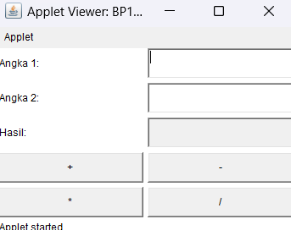

1. /*

* Click nbfs://nbhost/SystemFileSystem/Templates/Licenses/license-default.txt to change this license

* Click nbfs://nbhost/SystemFileSystem/Templates/Classes/Applet.java to edit this template

*/

package BP1_M1_P1_Bayu;

import java.applet.Applet;

import java.awt.Color;

import java.awt.Graphics;

import java.awt.event.ActionEvent;

import java.awt.event.ActionListener;

import javax.swing.Timer;

public class BP1_M2_Tugas2_Bayu_AppleteAnimasi extends Applet implements ActionListener {

private int ballX = 0;

private int ballY = 100;

private int ballSize = 30;

private int direction = 1;

private int speed = 5;

private Timer timer;

@Override

public void init() {

timer = new Timer(20, this);

timer.start();

}

@Override

public void paint(Graphics g) {

g.clearRect(0, 0, getWidth(), getHeight());

g.setColor(Color.GREEN);

g.fillOval(ballX, ballY, ballSize, ballSize);

}

@Override

public void actionPerformed(ActionEvent e) {

ballX += speed * direction;

if (ballX >= getWidth() - ballSize || ballX <= 0) {

direction *= -1;

}

repaint();

}

}

